Date: 8/27/2024

To: California Optical Providers for Medi-Cal Members Eyewear Benefits

From: California Prison Industry Authority • 560 East Natoma Street • Folsom, California 95630-2200

Subject: Changes to Santa Clara County Optical Lab Assignments

Please be advised your location’s optical lab assignments for manufacturing and customer service needs will change from Valley State Prison lab to CSP Solano lab effective Monday September 16th, 2024.

To avoid delays in orders, please select the correct lab location when printing labels from the Unity Courier pull-down menu for pick-up services.

Lab assignments for your location can be identified by the name and address in the upper right-hand corner of your Rx order printouts.

Please share this information with your respective teams.

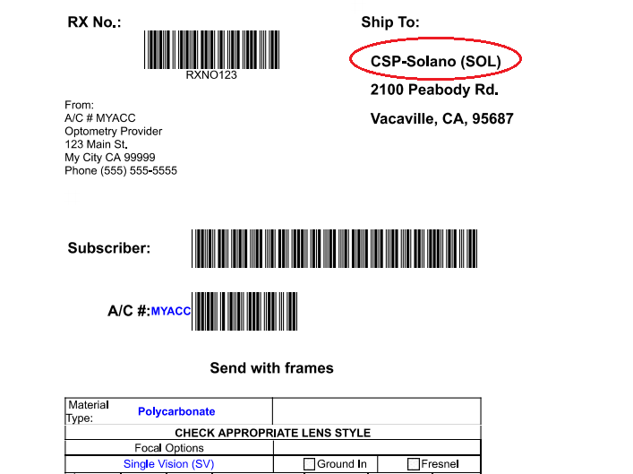

For additional information and updates please visit our login page area and FAQ sections of our on-line ordering website.

Thank you,

CALPIA Operations Team

